How much will it cost to create new workplaces in Ukraine in the post-war period?

# 

# Relevance of the study

The ongoing full-scale Russian invasion has presented Ukraine with significant macroeconomic challenges, exacerbating the country's already struggling economy. By the start of 2023, the National Bank of Ukraine had reported a staggering 2.0 million individuals unemployed within Ukraine. Moreover, the conflict has forced nearly 5 million people to seek refuge in Europe and other countries, while over a million others have been drafted into the military. As the war eventually comes to an end, a considerable portion of the Ukrainian population may find themselves at risk of long-term unemployment, which poses a critical social issue that demands immediate attention, robust investments, and innovative policies.

To address this pressing concern, it is imperative to thoroughly investigate the cost of creating new workplaces in Ukraine during the post-war period. Such an investigation has not yet been conducted, despite its relevance in understanding the scale of investments required to foster healthy employment rates. Incorporating this issue into Ukraine's recovery plan is essential, as it will provide a framework for implementing effective strategies to generate sustainable employment opportunities.

Estimating the necessary investments needed to rejuvenate the job market will prove invaluable to the Ministry of Finance, enabling them to project and allocate appropriate expenditures in the national budget. By determining the financial resources required to create a robust and diverse range of workplaces, the Ministry can better strategize and allocate funds to support job creation initiatives. This will not only facilitate the reintegration of the population into the labour market but also stimulate economic growth and stability in the long run.

It is worth considering that the study of the cost of creating a workplace in Ukraine should encompass various aspects beyond mere financial investment. Factors such as infrastructure development, vocational training programs, entrepreneurship support, and regulatory reforms should also be taken into account. By taking a holistic approach, policymakers and stakeholders can develop comprehensive strategies that address the multifaceted challenges hindering employment opportunities in the aftermath of the war.

Ultimately, a thorough investigation into the cost of creating workplaces in post-war Ukraine is vital for formulating effective policies and securing the necessary investments to achieve healthy unemployment. By integrating this research into Ukraine's recovery plan, the government can provide the framework and financial support needed to revitalise the job market, promote social stability, and foster sustainable economic development.

# Goal of research

The target of the article is to explore how much investment should Ukraine spend to return to the pre-war unemployment rate. Further, it will be shown how investments can affect the unemployment rate.

# Literature review

According to different economic theories, the relationship between gross capital formation (formerly gross domestic investment) and unemployment can be understood in various ways.

1. Classical Theory: Classical economists argue that any disturbances in an economy, including high unemployment or stagnant economic growth, will automatically correct themselves in the long run ([Edwards 1959](https://www.mdpi.com/2227-7099/8/2/26#B12-economies-08-00026)). They believe that unemployment will disappear without the need for specific policy interventions.
2. Keynesian Theory: Keynesian theory holds that unemployment is primarily caused by a lack of aggregate demand in the economy ([Keynes 1936](https://www.mdpi.com/2227-7099/8/2/26#B17-economies-08-00026)). According to this view, authorities should implement appropriate policies such as expansionary fiscal or monetary measures to address unemployment and stimulate economic growth. Keynesian economists argue that unemployment results from inadequate policies, changes in economic structures, and a lack of education that aligns with labour market needs.
3. Balance Theory of Capital Formation: The balance theory of capital formation is particularly relevant for developing countries with lower economic growth rates and higher population sizes. This theory suggests that the government should invest in industrial capital goods across various sectors to achieve balanced employment growth ([Krishna and Perez 2005](https://www.mdpi.com/2227-7099/8/2/26#B19-economies-08-00026)). By spreading capital goods throughout the economy, employment opportunities can be created in multiple sectors, leading to improved economic growth and a decrease in the unemployment rate.

# Theoretical concept

Research is based on the New Keynesian framework of economics. The New Keynesian framework provides a comprehensive and coherent framework for analyzing macroeconomic fluctuations, understanding the role of policy interventions, and guiding policy decisions to stabilize the economy.

According to the Keynesian framework, changes in unemployment are primarily driven by fluctuations in aggregate demand. When aggregate demand is low, there is a surplus of goods and services, which leads to a decrease in prices, reduced output, and layoffs, increasing unemployment. Conversely, when aggregate demand is high, there is a shortage of goods and services, which leads to an increase in prices, increased output, and hiring, decreasing unemployment. The Keynesian model argues that government intervention can be used to stimulate aggregate demand and reduce unemployment.

[Unemployment in an Estimated New Keynesian Model: NBER Macroeconomics Annual: Vol 26 (uchicago.edu)](https://www.journals.uchicago.edu/doi/full/10.1086/663994)

[New Keynesian economics - Wikipedia](https://en.wikipedia.org/wiki/New_Keynesian_economics)

# Model

The study was conducted using regression analysis according to New Keynesian model. Based on theory, our basic unemployment model will look like this:

(1)

where is unemployment rate, ADPW is aggregate demand for one worker.

The aggregate demand (AD) represents the total amount of goods and services demanded in an economy at a given price level. It is usually expressed as:

AD = C + I + G + (X - M), (2)

where:

* C represents consumer spending, which includes household consumption expenditures on goods and services.
* I represents investment, which includes business investment in capital goods, such as machinery and equipment, and residential investment, such as housing.
* G represents government spending, which includes government expenditures on goods and services.
* X represents exports, which are the goods and services produced domestically and sold to other countries.
* M represents imports, which are the goods and services produced in other countries and purchased domestically.

The (X - M) term in the formula represents the net exports.

Aggregate demand for one able-bodied person calculation formula is:

(3)

where AD is aggregate demand, TLF is number of total labour force in a country.

ADPW will help control for abrupt changes in number of labour force. It is easier to understand on example. For instance, Ukraine in 2023 has 10 million workers and 5 million able-bodied persons as refugees and aggregate demand X. ADPW will be . We assume that after the war refugees will return home. In the short-run they will not be able to significantly increase aggregate demand, because there will be no work places in the country, so refugees will not be able to work. ADPW will be . Therefore, our model will show a higher unemployment rate.

We don’t take into account non-working people, because Ukraine has solidary pension system. It means that Ukrainian government redirects a part of income from working people towards non working people. Therefore, aggregate demand is generated predominantly by working people.

Imagine that we have bare AD. After returning of refugees, AD will not change by assumption and overall input data will not change. Therefore, model will show same unemployment rate as before returning refugees.

From the structure of model and structure of AD, we can understand the relationship between investments and unemployment rate. Change the investments, it is possible to manipulate unemployment rate.

# Method

We stopped at Tobit regression for our investigation, because UR has range (0, y*).

We considered also ARIMAX model, but we faced with non-stationarity of data.

Model (1) under OLS will look like this:

(4)

where interception, elasticity of aggregate demand per unemployed person.

There is a disadvantage of Tobit model, that we are only able to interpret coefficient via marginal effect in certain point.

# Assumption

The main assumption is that the fluctuations in aggregate demand will cause inverse fluctuations in unemployment for countries.

On practice, it means that coefficient in (4) is expected to have negative sign.

# Data

Model was evaluated using World Bank data. Except Ukraine, Poland and Romania were taken as candidates to check the assumption.

Indicators for which datasets were taken:

* Consumer spending (C) (in constant 2015 US dollars)
* Investment (I) (in constant 2015 US dollars)

In the World Bank investment variable is called gross capital formation. is Gross capital formation consists of outlays on additions to the fixed assets of the economy plus net changes in the level of inventories. Fixed assets include land improvements (fences, ditches, drains, and so on); plant, machinery, and equipment purchases; and the construction of roads, railways, and the like, including schools, offices, hospitals, private residential dwellings, and commercial and industrial buildings. Inventories are stocks of goods held by firms to meet temporary or unexpected fluctuations in production or sales, and "work in progress." According to the 2008 SNA, net acquisitions of valuables are also considered capital formation.

* Government spending (G) (in constant 2015 US dollars)

In the World Bank government spending variable is called general government final consumption. General government final consumption expenditure (formerly general government consumption) includes all government current expenditures for purchases of goods and services (including compensation of employees). It also includes most expenditures on national defense and security, but excludes government military expenditures that are part of government capital formation.

* Net export (X-M) (in constant 2015 US dollars)
* Total labour force (TLF)
* Unemployment rate (U) (in percentages)

# After-war unemployment forecast issues

We have all the information to estimate the pre-war model of unemployment, but there are a few challenges with the war and after-war unemployment forecast.

The two main issues is to forecast unemployment rate in absence of input data for 2022-2023 and that model does not take into the account the losses and destructions caused by the war.

The possible solution to the first problem is to imply some assumptions about the state of aggregate demand in 2022-2023.

The second problem requires additional adjustments to the model. Therefore, we will use the model just for modelling unemployment rate changes caused by the recession.

Another problem arises from forecasting changes in the next period’s aggregate demand caused by investments in the previous period.

# Performance in R

## Data analysis and visualisation

Correlations between the unemployment rate and ADPW for countries:

* Ukraine **(the result demonstrated in the Figure 1)**
* Poland **(the result demonstrated in the Figure 2)**
* Romania **(the result demonstrated in the Figure 3)**

Ukraine and Romania have a moderate correlation between ADPW and UR.

Poland has a strong correlation between ADPW and UR.

Data visualisation:

* Ukraine**(Figure 4 and Graph 1)**

Ukrainian ADPW tended to increase from 1995 to 2005. Then it started stagnating. ADPW has not gone higher than 6183$.

Ukrainian UR tends to fluctuate around the mean 8.729259 **(shown in the Figure 5)**

Starting from 1995, it has not gone below the 6% level.

* Poland

Polish ADPW shows constant growth starting from 1995 **(Graph 2)**.

It reached its peak (38141 $) in 2021 **(Figure 7 )**.

Poland had a huge unemployment rate until 2007 **(shown in the Graph 3)**. In the last decade, it tends to decrease and reached a minimum of 3.16 % in 2020 **(Figure 8).**

* Romania

Romania, like Poland, shows constant APW growth starting from 1995. It reached its peak (30152 $) in 2021**(shown in the Graph 4)**.

The Romanian unemployment rate was fluctuating around 6,5% until 2015. Then it showed a decreasing trend **(shown in the Graph 5)**.

**Test the assumption**

* Ukraine

The coefficient on log(ADPW) is statistically significant at a 1% level and has a negative sign **(Figure 9)**. The sign is expected according to the New Keynesian framework. We can’t interpret the coefficient on log(ADPW), because we used the Tobit model.

* Poland

The coefficient on log(ADPW) is statistically significant at 0.1% level and has a negative sign **(Figure 10)**. Sign is expected according to the New Keynesian framework. We can’t interpret the coefficient on log(ADPW), because we used the Tobit model.

* Romania

The coefficient on log(ADPW) is statistically significant at a 1% level and has a negative sign **(Figure 11)**. The sign is expected according to the New Keynesian framework. We can’t interpret the coefficient on log(ADPW), because we used the Tobit model.

Generally, all the coefficients are statistically significant and have expected signs. It allows us to say that there is empirical evidence of the New Keynesian framework. Increasing aggregate demand leads to decreasing in the unemployment rate.

Therefore, the model is a valid instrument and can be used for forecasting.

# How does the model work in war?

It is important to compare the predicted unemployment rate of our model with the actual unemployment rate during wartime. These results will demonstrate the relevance of the model in accurately predicting unemployment during times of crisis.

As it was mentioned earlier, we should deal with some issues modelling UR during the war.

* Absence of data

The model requires only one input variable, denoted as ADPW. However, this variable is the result of dividing two economic variables, namely AD and TLF.

Let’s consider these variables separately.

We can make several assumptions about AD state during the war:

1. We can assume that the aggregate demand (AD) in 2022 decreased similarly to the decrease of AD observed in 2020, with an additional 30% recession. 2020 was chosen as the base year because it marked the beginning of the COVID-19 pandemic, which caused a huge economic shock, especially in AD.
2. To estimate the AD for 2023, we can take the AD of 2022 and multiply it by the expected growth in 2023 of 3%.

We can estimate TLF similarly subtracting the number of workable refugees. We assume the number of the labour force the same for 2022 and 2023 years.

* War externalities

Our model directly does not take into the account all war externalities that can cause the deviation of modeled UR from actual UR. Such externalities are hard to capture, especially in case of absence of any economic data.

# Estimation of TLF

Since February 24, 2022, when the large-scale Russo-Ukrainian war began, 9.3 million people have left Ukraine. However, 7.4 million Ukrainians have managed to return home. Currently, there are 2.1 million Ukrainian citizens abroad.

In total, the proportion of children under 16 and adults over 60 in Ukraine is 37%, while the percentage of working-age adults is 63%. Let's assume that the same proportion applies among refugees, so the number of working-age refugees is:

<https://zakordon.24tv.ua/skilki-ukrayinskih-bizhentsiv-perebuvaye-za-kordonom-svizhi-dani_n2184464>

Before the war, the number of working-age population was 20 285 701 individuals. If we subtract the number of refugees, the current working-age population stands at

We subtract working-age refuges and do not consider them while calculating UR, because they do not generate demand within Ukraine.

# Model predictions for war-time period (2022-2023)

* 2022 year

AD in 2022 year: 78547482847.0499 (**shown in the Figure 12**)

TLF in Ukraine in 2022 year: 18962701 **(shown in the Figure 13)**

Predicted UR: 9.72776 **(shown in the Figure 14)**

According to NBU [statistics](https://www.epravda.com.ua/rus/news/2023/01/17/696057/index.amp) in 2022 year, 3.2 million people searched for work within Ukraine. Unemployment rate without taking into the account refuges equals to:

%

Model prediction differs from real unemployment rate without taking into the account refuges on:

* 2023 year

AD in 2023 year: 80903907332.4614 **(shown in the Figure 15)**

TLF in Ukraine in 2022 year: 18962701 **(shown in the Figure 16)**

Predicted UR: 9.587996 **(shown in the Figure 17)**

According to new NBU [statistics](https://www.epravda.com.ua/rus/news/2023/01/17/696057/index.amp) in 2023 year, 2.0 million people searched for work within Ukraine. Unemployment rate within the country equals to

Predicted and real value differs on:

# Analysis of results

Analyzing the results, we can conclude that the model failed to predict UR in 2022 year and successfully predicted UR for 2023 year.

The reason for this inaccuracy of prediction could be unaccounted war externalities, especially internal and external migration in 2022. Unstable front and hostilities in 2022 forced many people to migrate. They had to find new place of living in other regions. After stabilization of the front, people returned to their living places and were back to their old workplaces. This fact can explain huge difference (1.2 million people) between the amount of people searching for the work in 2022 and 2023.

**How investment affects aggregate demand based on the Keynesian multiplier**

The Keynesian Multiplier is an economic concept that explains how changes in investment can influence aggregate demand. According to Keynesian economics, changes in aggregate demand, which is the total demand for goods and services in an economy, can have a significant impact on economic output and employment levels.

The Keynesian Multiplier suggests that an initial change in investment spending can have a multiplied effect on aggregate demand. When businesses increase their investment spending, such as by building new factories, purchasing equipment, or undertaking infrastructure projects, it stimulates economic activity and leads to increased production and income.

Here's how the Keynesian Multiplier works:

1. Initial Increase in Investment: Let's say there is an initial increase in investment spending by businesses. This could be due to factors such as improved business confidence, lower interest rates, or government incentives to encourage investment.
2. Increase in Aggregate Demand: The increased investment spending directly increases the demand for goods and services produced by other businesses. As a result, the businesses that supply these goods and services experience higher demand and, in turn, increase their production to meet the increased demand. This leads to an increase in aggregate demand in the economy.
3. Multiplier Effect: The increase in aggregate demand sets off a chain reaction. The businesses that receive the increased demand for their products and services, in turn, increase their spending, such as hiring more workers, increasing wages, and purchasing more inputs. This additional spending by businesses then becomes income for households and workers, who, in turn, increase their consumption and spending on goods and services. This process continues, with each round of increased spending leading to further increases in aggregate demand.
4. Total Impact on Aggregate Demand: The cumulative effect of this multiplier process is that the initial increase in investment spending has a multiplied impact on aggregate demand. The total increase in aggregate demand is larger than the initial increase in investment.

By influencing aggregate demand, changes in investment can have a significant impact on economic output, employment levels, and overall economic growth. In times of economic downturns, governments often use fiscal policies, such as increasing public investment, to stimulate the economy and boost aggregate demand through the Keynesian Multiplier effect.

[What Is the Multiplier Effect? Formula and Example (investopedia.com)](https://www.investopedia.com/terms/m/multipliereffect.asp)

# Calculation of impact of investments on aggregate demand

Our method is based on Keynesian multiplier effect theory. To calculate the impact of investments on aggregate demand, we run linear regression AD in period on investments in period .

Regression formula for investments:

(5)

Correlation for between investments in the first period and aggregate demand in the second period for Ukraine: 0.6806211**(shown in the Figure 18)**

Correlation is medium.

Regression for AD shown in the Figure 19

The coefficient on investments in the first period is statistically significant at 0,1%. We have strong evidence of the effect of investments on aggregate demand.

The magnitude of the coefficient is 1.486. It means that increasing of 1$ investments in the first period leads to increasing of 1.486$ in aggregate demand in the second period.

Residuals are normally distributed **(shown in the Figure 20)**

We can conclude that there is no bias in our regression.

We will this model further to calculate the effect of post-war investments on the growth of aggregate demand.

**How many refugees are going to return?**

According to the [survey](https://www.bing.com/search?pglt=41&q=%D1%87%D0%B8+%D0%BF%D0%BB%D0%B0%D0%BD%D1%83%D1%8E%D1%82%D1%8C+%D0%B1%D1%96%D0%B6%D0%B5%D0%BD%D1%86%D1%96+%D0%BF%D0%BE%D0%B2%D0%B5%D1%80%D1%82%D0%B0%D1%82%D0%B8%D1%81%D1%8C+%D0%B2+%D1%83%D0%BA%D1%80%D0%B0%D1%97%D0%BD%D1%83&cvid=ef03f91662e54760873a77f4eb58a768&aqs=edge..69i57j0l8.13489j0j1&FORM=ANNTA1&PC=U531&ntref=1), 36% of Ukrainians (refugees) plan to return home, so out of 2 100 000 people, only 756 000 will return, of which 476 280 will be of working age. Therefore, after the war, the number of working-age population will be:

**Scenarios for the end of the war**

We consider three different scenarios of ending conflict:

* suspension of hostilities as of 2023
* liberation of the territory as of February 24, 2022
* liberation of the territory to the state of the borders of 1991

All three variants imply different timing, amount of labour force, further destruction and economic loss. Calculation of investments directly depends on the factors above. It makes sense to calculate only after the end of the war using this method.

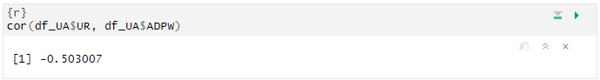

Figure 1. Correlations between the unemployment rate and ADPW for Ukraine

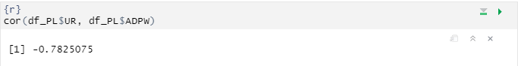

Figure 2. Correlations between the unemployment rate and ADPW for Poland

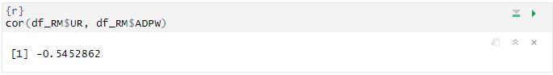

Figure 3. Correlations between the unemployment rate and ADPW for Romania

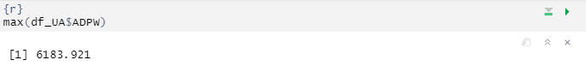

Figure 4. The highest Ukrainian ADPW

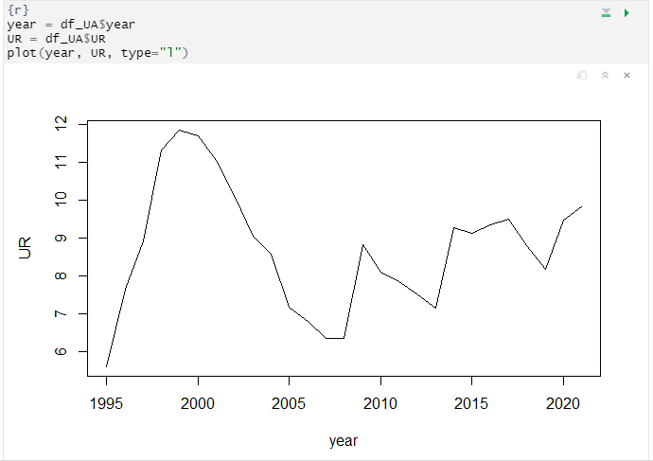

Graph 1. Ukrainian ADPW tended

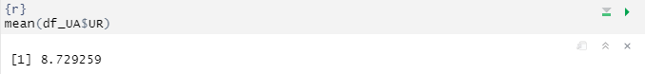

Figure 5. Ukrainian UR tends to fluctuate around this mean

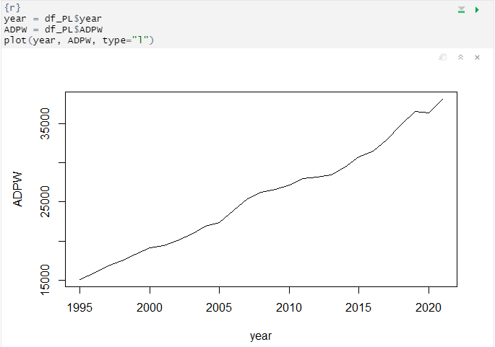

Graph 2. Polish ADPW

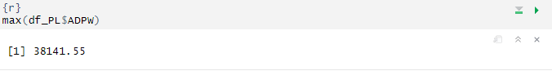

Figure 7. The peak of Polish ADPW

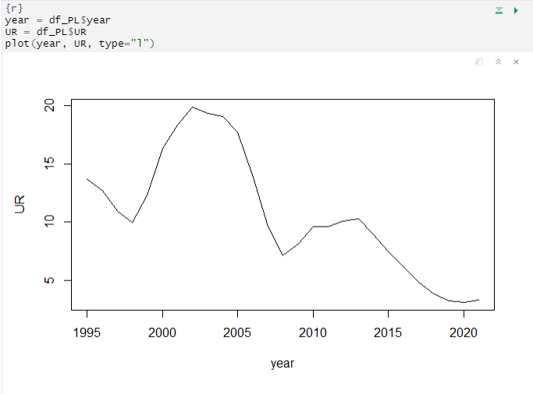

Graph 3. Unemployment rate until in Polish

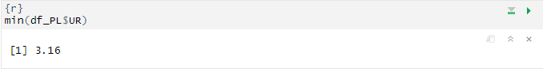

Figure 8. Minimum rate of unemployment in Polish

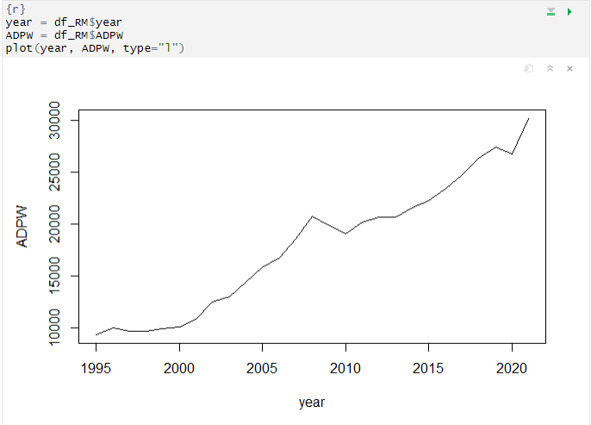

Graph 4. Romanian ADPW

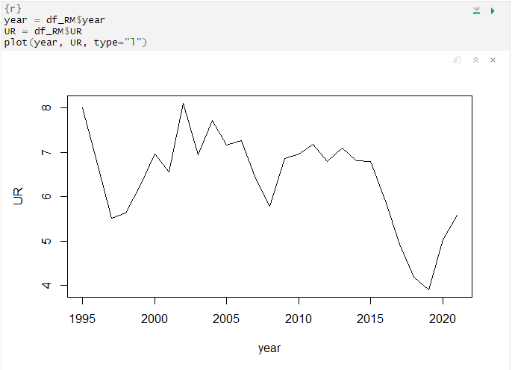

Graph 5. Romanian unemployment rate

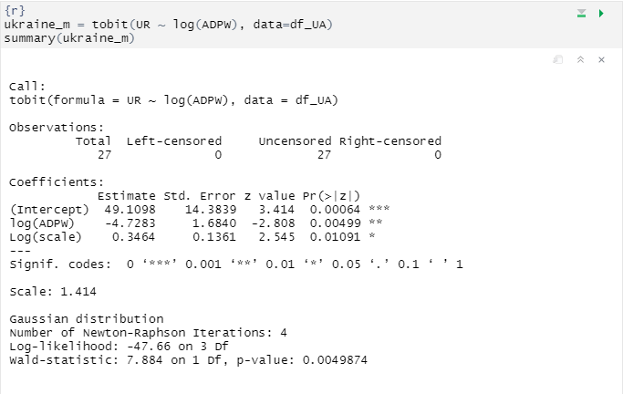

Figure 9. Test assumption for Ukraine

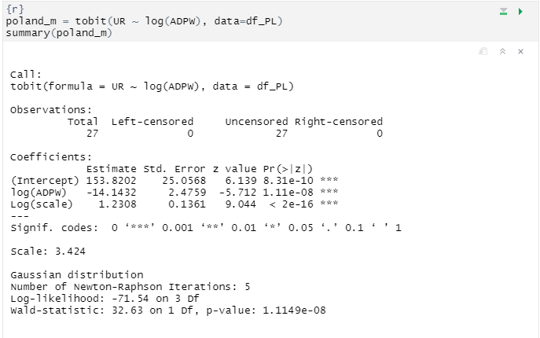

Figure 10. Test assumption for Poland

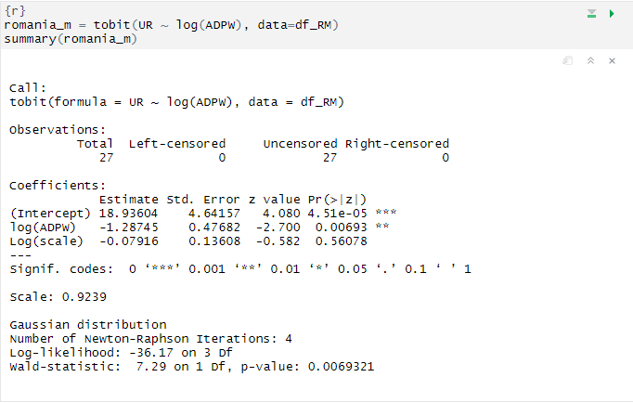

Figure 11. Test assumption for Romania



Figure 12. AD in 2022



Figure 13. TLF in Ukraine in 2022

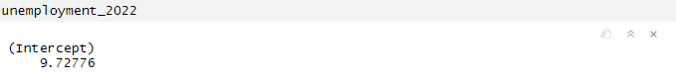

Figure 14. Predicted UR



Figure 15. AD in 2023 year



Figure 16. TLF in Ukraine in 2022 year

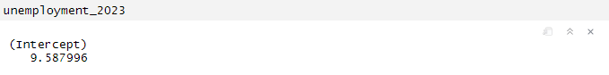

Figure 17. Predicted UR

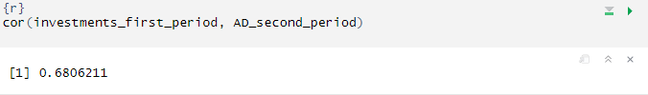

Figure 18.Correlation for between investments in the first period and aggregate demand in the second period for Ukraine

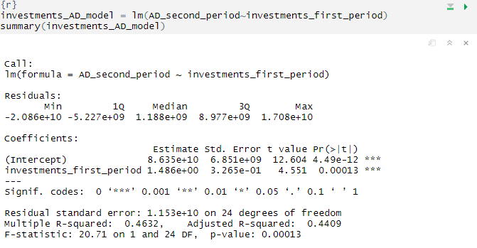

Figure 19. Regression for AD

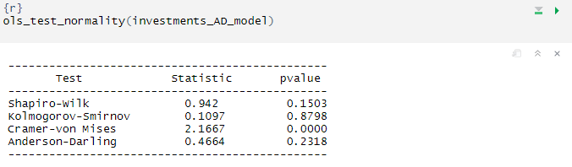

Figure 20. Residuals are distributed